Practical activity: Extraction of iron on a match head
Practical Guide – Extraction of Iron on a Match Head

Aim: To reduce iron(III) oxide with carbon on a match head to produce iron
Notes and guidance
You may wish to have students collect the equipment for this themselves from communal trays at the front of the lab. This will help them to develop their skills of equipment recognition and organisation. However, if this is impractical, ask your technician colleagues if they are able to set up individual sets at student workstations. Ensure each group has sufficient space to use a Bunsen burner and handle chemicals safely.

You should demonstrate before the practical starts that none of the chemicals used in this reaction are magnetic. You can do this by holding a strong magnet to the side of a glass jar containing the chemicals. You can contrast this with iron, which is magnetic.

This is a relatively straightforward practical, but on this small scale it may prove to be a little fiddly for some. If your students struggle to follow written instructions, it is advisable to stop the class after each step and deliver instructions for how to proceed. An added advantage of this is that you can add extra theory into your narration and explain why each step is being done.

The equation for this reaction is:

iron(III) oxide + carbon → iron + carbon dioxide

2Fe₂O₃(s) + 3C(s) → 4Fe(s) + 3CO₂(g)

Iron is less reactive than carbon, therefore the carbon reduces the iron oxide (removes the oxygen) and metallic iron is formed.

The purpose of sodium carbonate, which fuses easily, is to bring the carbon and iron oxide into close contact.

Risk Assessment Notes
A risk assessment must be completed for this practical. The risk assessment should be specific to the class involved and written only by the teaching member of staff. For more guidance refer to CLEAPSS. It is good practice for students to wear safety spectacles during all class practicals and demos.

Care should be taken when working with Bunsen burners. When not in use, they should be set to ‘safety flame’.

Sodium carbonate – CLEAPSS Hazcard HC095A
Iron(III) oxide powder – CLEAPSS Hazcard HC055A

This experiment works best with non-safety or ‘strike anywhere’ matches with a pinkish-red head. Only give students one match per group to remove the temptation for them to play with and waste matches.

Equipment Per Group | Chemicals:  - Iron(III) oxide powder (small amount in plastic weighing boat/watch glass)  - Sodium carbonate powder (small amount in plastic weighing boat/watch glass)  - Water (in a small beaker)  - Match (non-safety)  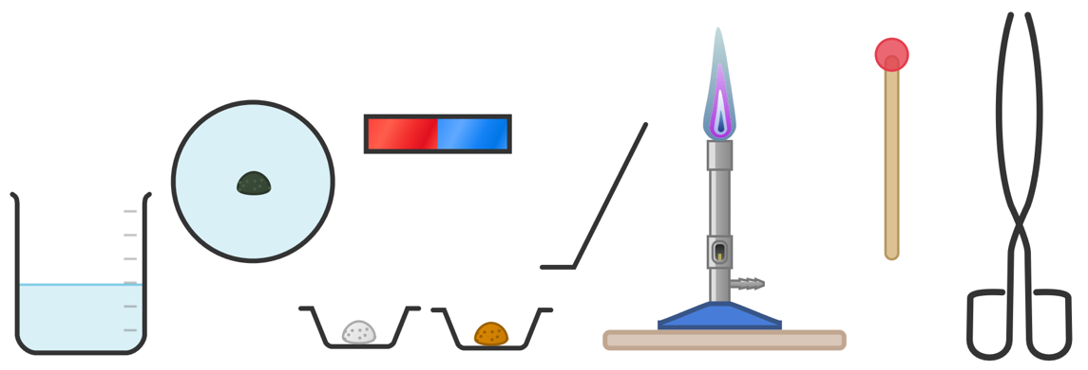
Apparatus:
- Tongs
- Weighing boats
- Beaker
- Plastic petri dish
- Spatula
- Bunsen Burner
- Heatproof Mat
- Bar magnet

Method |  | Questions To Ask Students During The Practical
- Ensure you have easy access to small amounts of the iron(III) oxide and sodium carbonate powders in small weighing boats and water in a small beaker.  - Moisten the head of a match in the beaker of water.  - Gently roll the match head in the sodium carbonate powder and then the iron(III) oxide powder.  - Set your Bunsen burner to a blue flame.  - Holding the match in the tongs, position it in the hottest part of the Bunsen flame so it flares and burns.  - Remove the match from the flame before it burns more than halfway along its length and hold it in the air to cool.  - Drop the match into the plastic petri dish and crush the charred end with the back of a metal spatula.  - Attach the lid of the petri dish and use the magnet to investigate whether the product of your reaction is magnetic. |  | - Why do we work with a small amount of these powders as opposed to dipping the match in a stock bottle? (To avoid contaminating and wasting the stock of the chemical.)  - What is the function of the sodium carbonate powder in this reaction? (Sodium carbonate fuses easily and brings the carbon and iron oxide into close contact.)  - Describe the what is happening during this reaction. (Iron is less reactive than carbon, therefore the carbon reduces the iron oxide [removes the oxygen] and metallic iron is formed.)  - Why do we set the Bunsen burner to safety flame when we are not using it? (The safety flame is less hot and more visible, making it much safer.)  - Why do we allow the match to cool before dropping it into the petri dish? (The petri dish is made of plastic and the match may melt it if it is hot.)  - Why must we avoid the magnet making direct contact with the product of our reaction? (When small bits of magnetic materials get stuck to a magnet they can be incredibly difficult to remove.)
Clearing up
It is important that equipment is returned to the prep room in good order. If safe to do so, rinse used equipment and put it in the used equipment tray. If the trays arrived on a trolley, students must return all trays and equipment to that trolley. Anything dirty needs to be placed into a separate container for washing up. Never put dirty equipment back into a tray with clean equipment.

Equipment may be hot after heating. If it is too hot to clear away safely by the end of the lesson, alert the technician.

Technician Notes
Discuss this practical with the class teacher ahead of time. Ensure they have considered the risks of this practical and are confident with the techniques used. If necessary, provide them with the CLEAPSS hazcards (identified in the risk section section above) so they are comfortable with the chemicals to be used and how to use and dispose of them safely.

Sodium carbonate – CLEAPSS Hazcard HC095A
Iron(III) oxide powder – CLEAPSS Hazcard HC055A

This experiment works best with non-safety or ‘strike anywhere’ matches with a pinkish-red head.

You may wish to trial this experiment first to ensure it works well with the matches and magnets you are using. Discuss the practical with the class teacher in case they would also like to have a practice run at the method.

